**A SEMINAR REPORT ON**

3D OPTICAL DATA STORAGE TECHNOLOGY

A SEMINAR REPORT SUBMITTED IN PARTIAL FULFILLMENT OF THE REQUIREMENT FOR THE AWARD OF THE DEGREE OF

MASTER OF TECHNOLOGY

IN

EMBEDDED SYSTEMS & VLSI DESIGN

SUBMITTED BY

K.KEERTHI

18S11D7006



#### DEPARTMENT OF ELECTRONICS AND COMMUNICATION ENGINEERING

#### MALLA REDDY INSTITUTE OF TECHNOLOGY AND SCIENCE

**MAISAMMAGUDA, DHULAPALLY, SECUNDERABAD-500014**

**(2018-2019)**

**Malla Reddy Institute of Technology and Science**

**Maisammaguda, RangaReddy .**



**BONAFIDE CERTIFICATE**

Certified that this technical seminar entitled “3D OPTICAL DATA STORAGE TECHNOLOGY **”,** being submitted by **K.KEERTHI** bearing roll no **18S11D7006** in partial fulfillment for the award of Degree of Master of Technology in **EMBEDDED SYSTEMS & VLSI DESIGN**, during the academic year **2018-19**.

Head of the Department, ECE

**ACKNOWLEDGEMENT**

It is great pleasure for me to express my grateful thanks to my honourable principal **Dr.K.Ravindra,** who had inspired a lot through his speeches. He is the only personality who had given the meaning to the technological studies and told me to survive in this competitive world.

I express my deep sense of gratitude and heart full thanks to **N.Neelima,** head of the department of Electronics and Communication Engineering for her cheerful motivation and encouragement at each stage of this endeavour.I was highly indebted to her.

I record with pleasure our deep sense of gratitude to all staff members for their stimulating guidance and profuse assistance. I have received from them throughout the course of the seminar. I shall always cherish my association with their encouragement, approachability and freedom of thought and action I have enjoyed during this work. I wish to thank all staff members and my friends who have helped in completion of seminar.

**K.KEERTHI**

**(18S11D7006)**

**ABSTRACT**

In this paper, Storing data is an important task in our regular life,this process is having a great history as magnetic tapes,gramophone records,floppy disks,optical storage disks,flash cards and so on.So the change is in the amount of size of data it can store and the space occupied of disk.For this 3D optical type is going to be a best alternative.

.

**CONTENTS PAGE NO**

1. INTRODUCTION 1
2. OPTICAL RECORDING TECHNOLOGY 2
3. HISTORY AND OVERVIEW 3

A. HISTORY

B. OVERVIEW

1. PROCEDURE FOR CREATING WRITTEN DATA 9

1. WRITTEN BY NONREONANT MULTIPHOTON ABSORPTION

B.WRITTEN BY SEQUENTIAL MULTIPHOTON ABSORPTION

1. PROCEDURE FOR READING DATA 15
2. ADVANTAGES AND APPLICATIONS 23

1. CONCLUSION 24
2. REFERENCES 25

**LIST OF FIGURES PAGE NO**

1.OPTICAL READING TECHNOLOGY

2. COMPACT DISC 3

3. SCEMATIC REPRESENTATION OF ACROSS SCTION THROUGH

A 3D OPTICAL STORAGE 5

4. A HOLOGRAPHIC VIDEO DISC AND A DVD13 7

5. A BLUE RAY DISK 8

**1. INTRODUCTION**

3D optical data storage is the term given to any form of [optical](http://en.wikipedia.org/wiki/Optical)[data storage](http://en.wikipedia.org/wiki/Data_storage_device) in which information can be recorded and/or read with [three dimensional](http://en.wikipedia.org/wiki/Three-dimensional_space)[resolution](http://en.wikipedia.org/wiki/Optical_resolution) (as opposed to the [two dimensional](http://en.wikipedia.org/wiki/Two_dimensional) resolution afforded, for example, by [CD](http://en.wikipedia.org/wiki/CD)).

This innovation has the potential to provide petabyte-level mass storage on DVD-sized disks. Data recording and readback are achieved by focusing lasers within the medium. However, because of the volumetric nature of the data structure, the laser light must travel through other data points before it reaches the point where reading or recording is desired. Therefore, some kind of nonlinearity is required to ensure that these other data points do not interfere with the addressing of the desired point.

No commercial product based on 3D optical data storage has yet arrived on the mass market, although several companies are actively developing the technology and claim that it may become available soon.

**1**

## 2 . OPTICAL RECORDING TECHNOLOGY

Optical storage systems consist of a drive unit and a storage medium in a rotating disk form. In general the disks are pre-formatted using grooves and lands (tracks) to enable the positioning of an optical pick-up and recording head to access the information on the disk. Under the influence of a focused laser beam emanating from the optical head, information is recorded on the media as a change in the material characteristics.

The disk media and the pick-up head are rotated and positioned through drive motors controlling the position of the head with respect to data tracks on the disk. Additional peripheral electronics are used for control and data acquisition and encoding/decoding.

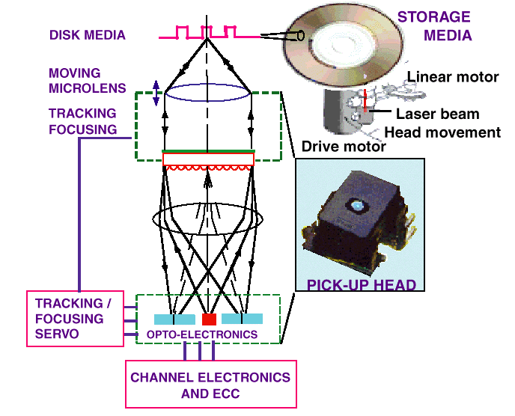

Fig 2.1: optical reading technology

**2**

STORAGE CAPACITY:

The storage capacity of an optical storage system is a direct function of spot size (minimum dimensions of a stored bit) and the geometrical dimensions of the media. A good metric to measure the efficiency in using the storage area is the areal density (MB/sq. in.). DATA TRANSFER RATE:

The data transfer rate of an optical storage system is a critical parameter in applications where long data streams must be stored or retrieved, such as for image storage or backup. Data transfer rate is a combination of the linear density and the rotational speed of the drive.

ACCESS TIME:

The access time of an optical storage system is a critical parameter in computing applications such as transaction processing; it represents how fast a data location can be accessed on the disk.

COST:

The cost of an optical storage system is a parameter that can be subdivided into the drive cost and the media cost. Cost strongly depends on the number of units produced, the automation techniques used during assembly, and component yields.

**3. HISTORY AND OVERVIEW**

1. **HISTORY**

The origins of the field date back to the 1950s, when Yehuda Hirshberg developed the [photochromic](http://en.wikipedia.org/wiki/Photochromic)spiropyrans and suggested their use in data storage. In the 1970s,ValeriBarachevskii demonstrated that this photochromism could be produced by two-photon excitation, and finally at the end of the 1980s Peter T. Rentzepis showed that this could lead to three-dimensional data storage. This proof-of-concept system stimulated a great deal of research and development, and in the following decades many academic and commercial groupshave worked on 3D optical data storage products and technologies. Most of the developed systems are based to some extent on the original ideas of Rentzepis. A wide range of physical phenomena for data reading and recording have been investigated, large numbers of [chemical](http://en.wikipedia.org/wiki/Chemical) systems for the medium have been developed and evaluated, and extensive work has been carried out in solving the problems associated with the optical systems required for the reading and recording of data. Currently, several groups remain working on solutions with various levels of development and interest in commercialization.

**B. OVERVIEW**

Current optical [data storage](http://en.wikipedia.org/wiki/Data_storage_device) media, such as the [CD](http://en.wikipedia.org/wiki/CD) and [DVD](http://en.wikipedia.org/wiki/DVD) store data as a series of reflective marks on an internal surface of a disc. In order to increase storage capacity, it is possible for discs to hold two or even more of these data layers, but their number is severely limited since the addressing laser interacts with every layer that it passes through on the way to and from the addressed layer. These interactions cause noise that limits the technology to approximately 10 layers. [3D](http://en.wikipedia.org/wiki/Three-dimensional_space) optical data storage methods circumvent this issue by using addressing methods where only the specifically addressed [voxel](http://en.wikipedia.org/wiki/Voxel) (volumetric pixel) interacts substantially with the addressing light. This necessarily involves nonlinear data reading and writing methods, in particular [nonlinear optics](http://en.wikipedia.org/wiki/Nonlinear_optics).

As an example, a prototypical 3D optical data storage system may use a disk that looks much like a transparent DVD. The disc contains many layers of information, each at a different depth in the media and each consisting of a DVD-like spiral track. In order to record information on the disc a [laser](http://en.wikipedia.org/wiki/Laser) is brought to a [focus](http://en.wikipedia.org/wiki/Focus_(optics)) at a particular depth in the media that corresponds to a particular information layer. When the laser is turned on it causes a [photochemical](http://en.wikipedia.org/wiki/Photochemical) change in the media. As the disc spins and the read/write head moves along a radius, the layer is written just as a DVD-R is written. The depth of the focus may then be changed and another entirely different layer of information written. The distance between layers may be 5 to 100 [micrometers](http://en.wikipedia.org/wiki/Micrometre), allowing >100 layers of information to be stored on a single disc.

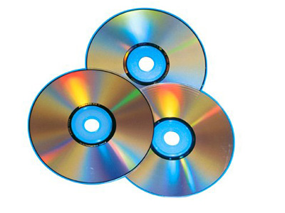

Fig 3.1 :compact disc

In order to read the data back (in this example), a similar procedure is used except this time instead of causing a photochemical change in the media the laser causes [fluorescence](http://en.wikipedia.org/wiki/Fluorescence). This is achieved e.g. by using a lower laser power or a different laser wavelength. The intensity or wavelength of the fluorescence is different depending on whether the media has been written at that point, and so by measuring the emitted light the data is read.

The size of individual chromophore[molecules](http://en.wikipedia.org/wiki/Molecules) or photoactive color centers is much smaller than the size of the laser focus (which is determined by the [diffraction limit](http://en.wikipedia.org/wiki/Diffraction_limit)). The light therefore addresses a large number (possibly even 109) of molecules at any one time, so the medium acts as a homogeneous mass rather than a matrix structured by the positions of chromophores.

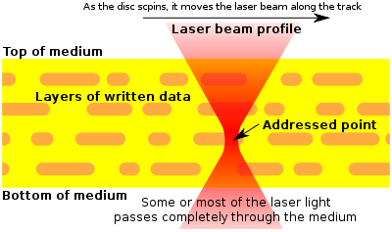

Fig 3.2: Schematic representation of a cross section through

a 3d optical storage disc

Schematic representation of a cross-section through a 3D optical storage disc (yellow) along a data track (orange marks).Four data layers are seen, with the laser currently addressing the third from the top. The laser passes through the first two layers and only interacts with the third, since here the light is at a high intensity.

**4. PROCEDUREFOR CREATING WRITTEN DATA**

Data recording in a 3D optical storage medium requires that a change take place in the medium upon excitation. This change is generally a photochemical reaction of some sort, although other possibilities exist. [Chemical reactions](http://en.wikipedia.org/wiki/Chemical_reactions) that have been investigated include [photoisomerizations](http://en.wikipedia.org/wiki/Photoisomerization), [photodecompositions](http://en.wikipedia.org/wiki/Photodecomposition) and [photobleaching](http://en.wikipedia.org/wiki/Photobleaching), and [polymerization](http://en.wikipedia.org/wiki/Polymerization) initiation. Most investigated have been photochromic compounds, which include [azobenzenes](http://en.wikipedia.org/wiki/Azobenzene), [stilbenes](http://en.wikipedia.org/wiki/Stilbene), spiropyrans, fulgides and [diarylethenes](http://en.wikipedia.org/wiki/Diarylethene). If the photochemical change is [reversible](http://en.wikipedia.org/wiki/Reversible), then rewritable data storage may be achieved, at least in principle. Also, [multilevel recording](http://en.wikipedia.org/wiki/MultiLevel_Recording), where data is written in ‘[grayscale](http://en.wikipedia.org/wiki/Grayscale)’ rather than as on and off signals, is technically feasible.

**A.WRITING BY NONREONANT MULTIPHOTONABSORPTION**

Although there are many nonlinear optical phenomena, only multiphoton absorption is capable of injecting into the media the significant energy required to electronically excite molecular species and cause chemical reactions. [Two-photon absorption](http://en.wikipedia.org/wiki/Two-photon_absorption) is the strongest multiphoton absorbance by far, but still it is a very weak phenomenon, leading to low media sensitivity. Therefore, much research has been directed at providing chromophores with high two-photon absorption cross-sections.

Writing by 2-photon absorption can be achieved by focusing the writing laser on the point where the photochemical writing process is required. The wavelength of the writing laser is chosen such that it is not linearly absorbed by the medium, and therefore it does not interact with the medium except at the focal point. At the focal point 2-photon absorption becomes significant, because it is a nonlinear process dependent on the square of the laser [fluence](http://en.wikipedia.org/wiki/Fluence).

Writing by 2-photon absorption can also be achieved by the action of two lasers in coincidence. This method is typically used to achieve the parallel writing of information at once. One laser passes through the media, defining a line or plane. The second laser is then directed at the points on that line or plane that writing is desired.

The coincidence of the lasers at these points excited 2-photon absorption, leading to writing photochemistry.

**B.WRITING BYSEQUENTIAL MULTIPHOTON ABSORPTION**

Another approach to improving media sensitivity has been to employ [resonant](http://en.wikipedia.org/wiki/Resonant) two-photon absorption (also known as "1+1" or "sequential" 2-photon absorbance). Nonresonant two-photon absorption (as is generally used) is weak since in order for excitation to take place, the two exciting [photons](http://en.wikipedia.org/wiki/Photons) must arrive at the chromophore at almost exactly the same time. This is because the chromophore is unable to interact with a single photon alone. However, if the chromophore has an energy level corresponding to the (weak) absorption of one photon then this may be used as a [stepping stone](http://en.wiktionary.org/wiki/stepping_stone), allowing more freedom in the arrival time of photons and therefore a much higher sensitivity. However, this approach results in a loss of nonlinearity compared to nonresonant 2-photon absorbance (since each 1-photon absorption step is essentially linear), and therefore risks compromising the 3D resolution of the system.

**C.MICRO HOLOGRAPHY**

In micro[holography](http://en.wikipedia.org/wiki/Holography), focused beams of light are used to record submicrometre-sized [holograms](http://en.wikipedia.org/wiki/Hologram) in a photorefractive material, usually by the use of collinear beams. The writing process may use the same kinds of media that are used in other types of [holographic data storage](http://en.wikipedia.org/wiki/Holographic_data_storage), and may use 2-photon processes to form the holograms.

**D.DATA RECORDING DURING MANUFACTURING**

Data may also be created in the manufacturing of the media, as is the case with most optical disc formats for commercial data distribution. In this case, the user cannot write to the disc - it is a [ROM](http://en.wikipedia.org/wiki/Read-only_memory) format. Data may be written by a nonlinear optical method, but in this case the use of very high power lasers is acceptable so media sensitivity becomes less of an issue.

The fabrication of discs containing data molded or printed into their 3D structure has also been demonstrated. For example, a disc containing data in 3D may be constructed by sandwiching together a large number of wafer-thin discs, each of which is molded or printed with a single layer of information. The resulting ROM disc can then be read using a 3D reading method.

**E. OTHER APPROACHES TO WRITING**

Other techniques for writing data in three-dimensions have also been examined, including:

* Persistent [spectral hole burning](http://en.wikipedia.org/wiki/Spectral_hole_burning) (PSHB), which also allows the possibility of spectral [multiplexing](http://en.wikipedia.org/wiki/Multiplexing) to increase data density. However, PSHB media currently requires extremely low temperatures to be maintained in order to avoid data loss.
* Void formation, where microscopic bubbles are introduced into a media by high intensity laser irradiation.
* Chromophore poling, where the laser-induced reorientation of chromophores in the media structure leads to readable changes.

5.PROCEDURE FOR READING DATA

The reading of data from 3D optical memories has been carried out in many different ways. While some of these rely on the nonlinearity of the light-matter interaction to obtain 3D resolution, others use methods that spatially filter the media's linear response. Reading methods include:

* Two photon absorption (resulting in either absorption or fluorescence). This method is essentially [two-photon microscopy](http://en.wikipedia.org/wiki/Two-photon_microscopy).
* Measurement of small differences in the refractive index between the two data states. This method usually employs a [phase contrast microscope](http://en.wikipedia.org/wiki/Phase_contrast_microscope) or confocal reflection [microscope](http://en.wikipedia.org/wiki/Microscope). No absorption of light is necessary, so there is no risk of damaging data while reading, but the required [refractive index](http://en.wikipedia.org/wiki/Refractive_index) mismatch in the disc may limit the thickness (i.e. number of data layers) that the media can reach due to the accumulated random wavefront errors that destroy the focused spot quality.
* Linear excitation of fluorescence with confocal detection. This method is essentially [confocal laser scanning microscopy](http://en.wikipedia.org/wiki/Confocal_laser_scanning_microscopy). It offers excitation with much lower laser powers than does two-photon absorbance, but has some potential problems because the addressing light interacts with many other data points in addition to the one being addressed.
* [Second harmonic generation](http://en.wikipedia.org/wiki/Second_harmonic_generation) has been demonstrated as a method to read data written into a poled polymer matrix.
* [Optical coherence tomography](http://en.wikipedia.org/wiki/Optical_coherence_tomography) has also been demonstrated as a parallel reading method.

**A.MEDIA DESIGN**

The active part of 3D optical storage media is usually an [organic](http://en.wikipedia.org/wiki/Organic_chemistry)[polymer](http://en.wikipedia.org/wiki/Polymer) either [doped](http://en.wikipedia.org/wiki/Doped) or [grafted](http://en.wikipedia.org/wiki/Graft_copolymer) with the photochemically active species. Alternatively, crystalline and [sol-gel](http://en.wikipedia.org/wiki/Sol-gel) materials have been used.

### MEDIA FORM FACTOR

Media for 3D optical data storage have been suggested in several form factors:

* Disc: A disc media offers a progression from CD/DVD, and allows reading and writing to be carried out by the familiar spinning disc method.
* Card: A [credit card](http://en.wikipedia.org/wiki/Credit_card) form factor media is attractive from the point of view of portability and convenience, but would be of a lower capacity than a disc.
* Crystal, Cube or Sphere: Several [science fiction](http://en.wikipedia.org/wiki/Science_fiction) writers have suggested small solids that store massive amounts of information, and at least in principle this could be achieved with 3D optical data storage.

**B.MEDIA MANUAFCTURING**

The simplest method of [manufacturing](http://en.wikipedia.org/wiki/Manufacturing) - the [molding](http://en.wikipedia.org/wiki/Molding_(process)) of a disk in one piece - is a possibility for some systems. A more complex method of media manufacturing is for the media to be constructed layer by layer. This is required if the data is to be physically created during manufacture. However, layer-by-layer construction need not mean the sandwiching of many layers together. Another alternative is to create the medium in a form analogous to a roll of adhesive tape.

## C.DRIVE DESIGN

A drive designed to read and write to 3D optical data storage media may have a lot in common with CD/DVD drives, particularly if the form factor and data structure of the media is similar to that of CD or DVD. However, there are a number of notable differences that must be taken into account when designing such a drive, including

* Laser. Particularly when 2-photon absorption is utilized, high-powered lasers may be required that can be bulky, difficult to cool, and pose safety concerns. Existing optical drives utilize [continuous wave](http://en.wikipedia.org/wiki/Continuous_wave)[diode lasers](http://en.wikipedia.org/wiki/Diode_laser) operating at 780 nm, 658 nm, or 405 nm. 3D optical storage drives may require [solid-state lasers](http://en.wikipedia.org/wiki/Solid-state_laser) or pulsed lasers, and several examples use wavelengths easily available by these technologies, such as 532 nm (green). These larger lasers can be difficult to integrate into the read/write head of the optical drive.
* Variable spherical aberration correction. Because the system must address different depths in the medium, and at different depths the [spherical aberration](http://en.wikipedia.org/wiki/Spherical_aberration) induced in the [wavefront](http://en.wikipedia.org/wiki/Wavefront) is different, a method is required to dynamically account for these differences. Many possible methods exist that include optical elements that swap in and out of the optical path, moving elements, [adaptive optics](http://en.wikipedia.org/wiki/Adaptive_optics), and immersion lenses.
* Optical system. In many examples of 3D optical data storage systems, several wavelengths (colors) of light are used (e.g. reading laser, writing laser, signal; sometimes even two lasers are required just for writing). Therefore, as well as coping with the high laser power and variable spherical aberration, the optical system must combine and separate these different colors of light as required.
* Detection. In DVD drives, the signal produced from the disc is a reflection of the addressing laser beam, and is therefore very intense. For 3D optical storage however, the signal must be generated within the tiny volume that is addressed, and therefore it is much weaker than the laser light. In addition, fluorescence is radiated in all directions from the addressed point, so special light collection optics must be used to maximize the signal.
* Data tracking. Once they are identified along the z-axis, individual layers of DVD-like data may be accessed and tracked in similar ways to DVD discs. The possibility of using parallel or page-based addressing has also been demonstrated. This allows much faster [data transfer rates](http://en.wikipedia.org/wiki/Data_transfer_rate), but requires the additional complexity of [spatial light modulators](http://en.wikipedia.org/wiki/Spatial_light_modulator), signal imaging, more powerful lasers, and more complex data handling.

**D.COMPARISON WITH HOLOGRAPHIC DATA STORAGE**

3D optical data storage is related to (and competes with) [holographic data storage](http://en.wikipedia.org/wiki/Holographic_data_storage). Traditional examples of holographic storage do not address in the third dimension, and are therefore not strictly "3D", but more recently 3D holographic storage has been realized by the use of microholograms. [Layer-selection](http://en.wikipedia.org/wiki/LS-R) multilayer technology (where a multilayer disc has layers that can be individually activated e.g. electrically) is also closely related.

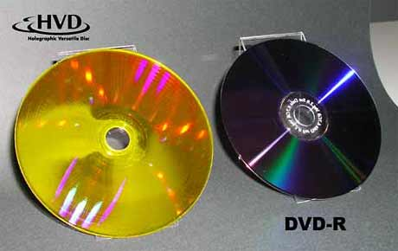

Fig5.1: A Holographic Video Disc and a DVD

Holographic data storage is a potential replacement technology in the area of high-capacity [data](http://en.wikipedia.org/wiki/Data) storage currently dominated by magnetic and conventional optical data storage. Magnetic and optical data storage devices rely on individual bits being stored as distinct magnetic or optical changes on the surface of the recording medium. Holographic data storage overcomes this limitation by recording information throughout the volume of the medium and is capable of recording multiple images in the same area utilizing light at different angles.Additionally, whereas magnetic and optical data storage records information a bit at a time in a linear fashion, holographic storage is capable of recording and reading millions of bits in parallel, enabling data transfer rates greater than those attained by traditional optical storage.

## RECORDING DATA

Holographic data storage captures information using an optical interference pattern within a thick, photosensitive optical material. Light from a single [laser](http://en.wikipedia.org/wiki/Laser) beam is divided into two separate optical patterns of dark and light pixels. By adjusting the reference beam angle, wavelength, or media position, a multitude of holograms (theoretically, several thousand) can be stored on a single volume.

## 5.4.2 [[edit](http://en.wikipedia.org/w/index.php?title=Holographic_data_storage&action=edit&section=2)] READING DATA

The stored data is read through the reproduction of the same reference beam used to create the [hologram](http://en.wikipedia.org/wiki/Hologram). The reference beam’s light is focused on the photosensitive material, illuminating the appropriate [interference pattern](http://en.wikipedia.org/wiki/Interference_pattern), the light [diffracts](http://en.wikipedia.org/wiki/Diffracts) on the [interference pattern](http://en.wikipedia.org/wiki/Interference_pattern), and projects the pattern onto a detector. The detector is capable of reading the data in parallel, over one million bits at once, resulting in the fast data transfer rate. Files on the holographic drive can be accessed in less than 200 milliseconds.

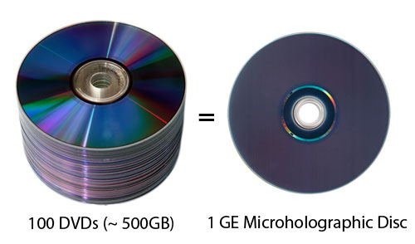

**6**

**E.COMPARISON WITH BLUE-RAY DISC**

Blue-ray Disc (official abbreviation BD) is an [optical disc](http://en.wikipedia.org/wiki/Optical_disc)[storage](http://en.wikipedia.org/wiki/Data_storage_device) medium designed to supersede the [DVD](http://en.wikipedia.org/wiki/DVD) format. The disc diameter is 120 mm and disc thickness 1.2 mm plastic [optical disc](http://en.wikipedia.org/wiki/Optical_disc), the same size as [DVDs](http://en.wikipedia.org/wiki/DVD) and [CDs](http://en.wikipedia.org/wiki/CD). Blu-ray Discs contain 25 [GB](http://en.wikipedia.org/wiki/Gigabyte) (23.31 [GiB](http://en.wikipedia.org/wiki/Gibibyte)) per layer, with dual layer discs (50 GB) being the norm for feature-length video discs. Triple layer discs (100 GB) and quadruple layers (128 GB) are available for BD-XL Blue-ray re-writer drives.

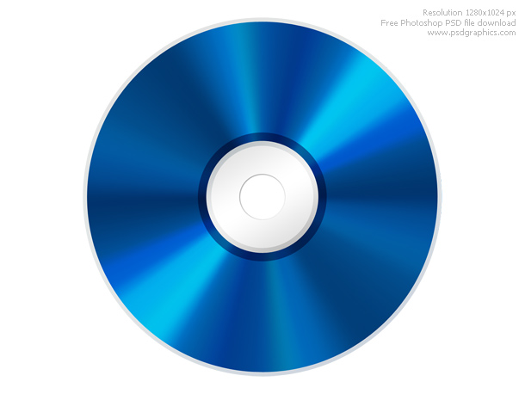

Fig 5.2: A Blue-ray Disc

Currently movie production companies have not utilized the triple or quadruple layer discs; most consumer owned Blue-ray players will not be able to read the additional layers, while newer Blue-ray players may require a firmware update to play the triple and quadruple sized discs. Compared to the 3D optical disks which will have around 100+ layers, the Blue-ray discs have much less storage capacity even the much newer quadruple layer discs. The first Blue-ray Disc prototypes were unveiled in October 2000, and the first prototype player was released in April 2003 in [Japan](http://en.wikipedia.org/wiki/Japan). Afterwards, it continued to be developed until its official release in June 2006.During the [high definition optical disc format war](http://en.wikipedia.org/wiki/High_definition_optical_disc_format_war), Blue-ray Disc competed with the [HD DVD](http://en.wikipedia.org/wiki/HD_DVD) format. [Toshiba](http://en.wikipedia.org/wiki/Toshiba), the main company that supported HD DVD, conceded in February 2008, releasing their own Blue-ray Disc player in late 2009.

**6.ADVANTAGES AND APPLICATIONS**

**A. ADVANTAGES**

* Terabyte data storage in an ordinary disc
* 1 diameter 50GB disc for data storage for mobiles
* More than 100 layer of information in a single disc
* More data storage in less space
* We can store 100s of movies in a single disc

**B. APPLICATIONS**

* Wide chance of storing data in a less space such as a DVD
* Servers
* Databases
* Social networking

**7. CONCLUSION**

3D optical data storage is the form of optical data storage which is really a good alternative for the data storage required in now a days life which is having a lot of data to store. As it can store about 217 DVD’s in a single disc.

**8. REFERENCES**

* Hunter, S., Kiamilev, F., Esener, S., et al., 1990, Appl. Opt., 29, 2058.
* Parthenopoulos, D.A and Rentzepis, P.M., 1989, Science, 245, 643.
* Dvornikov, A.S., Cokgor, I., McCormick, F.B., et al., 1996, Opt. Commun., 128, 205.
* Wang, M.M., Esener, S.C., McCormick, F.B., et al., 1997, Opt. Lett., 22, 558.
* Akimov, D.A., Zheltikov, A.M., Koroteev, N.I., et al., 1996, Kvantovaya Elektron., 23, 871.

Websites

* <http://en.wikipedia.org/wiki/3D_optical_data_storage>

<http://www.rsc.qut.edu.au/studentsstaff/training/Posters/QUT%20Research%20Poster_Sando.pdf>